**Simple Maths and Data Types Worksheet – Year 8 Computer Studies**

**INPUT Displays a message and waits for a user input!**

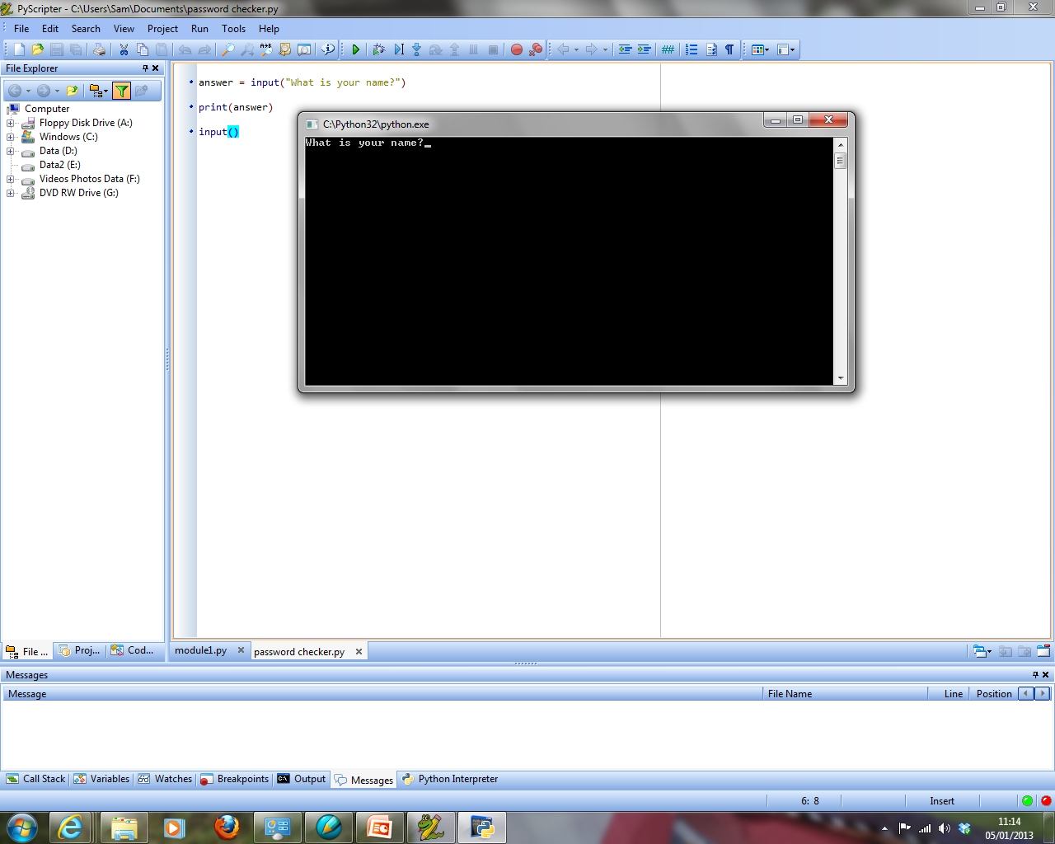**Things to remember:**

**PRINT just displays a message!**

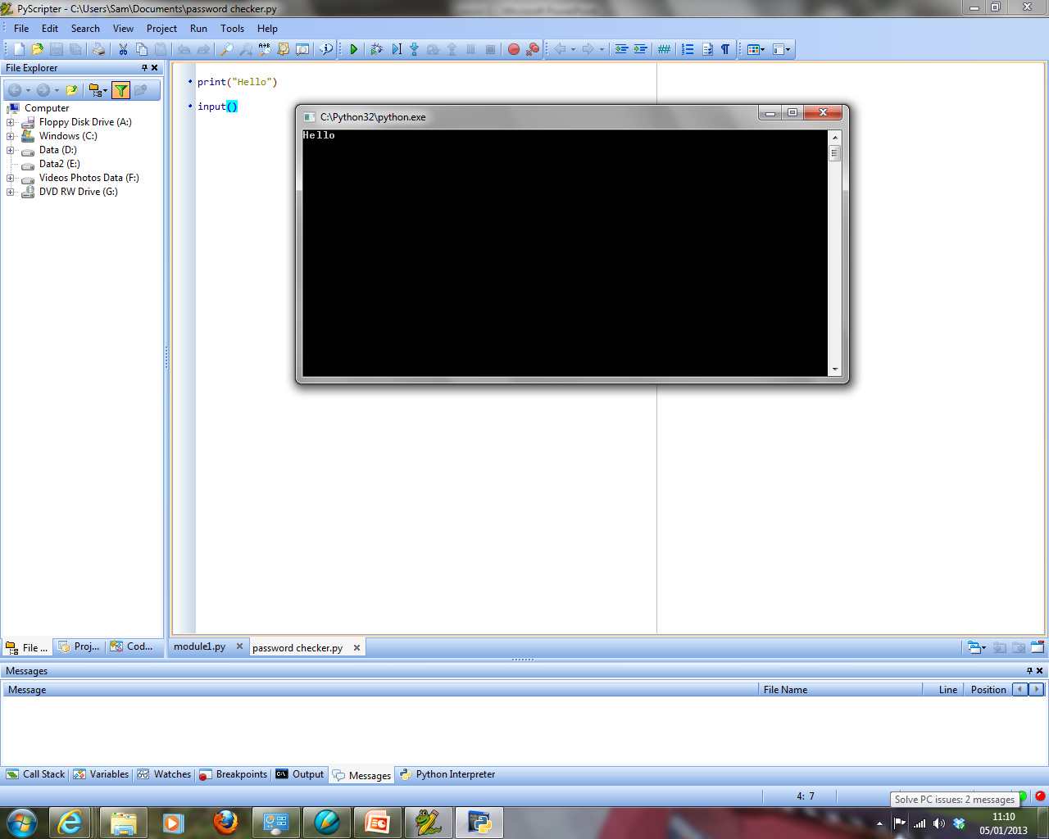



**So, it needs to equal a variable if we want to store what the user types in…**

**How to get the ‘Python Code’ doing Maths**

If we want our program to work with numbers we must tell the program that certain variables will hold numbers.

When we input a number into our program

**num1 = input(“please enter a number”)**

…python automatically sets the variable as a string *(a word, for example ‘****twenty’*** *instead of* ***20****)*

If we want to do maths with the ‘inputs’ we need to tell the computer that the variable contains a number (integer)

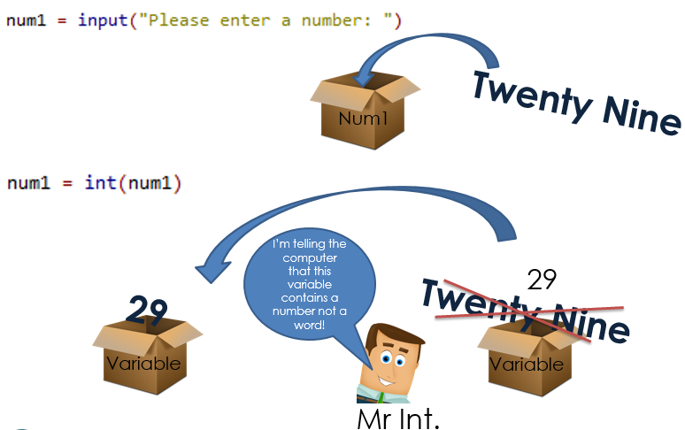

See below for examples of the **int function** in use so that calculations can be done in Python:

To the left you can see that two numbers have been entered and stored in variables num1 and num2.

As python stores inputs as strings we need to convert these variables into integers.

We do this performing the int function on each variable. Then we add them, store the result and print it to the screen.

**EXAMPLE 1 – Working with numbers**

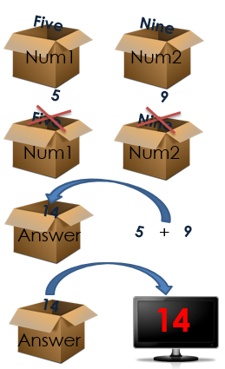

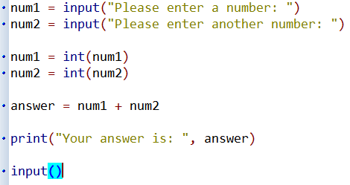

**Programming Activities**

The **guidance and examples** (shown above) will help with these tasks:

1. **Ask the user to input two numbers and add those numbers together**

To create a program to solve this you will need:

2 variables, each with an input statement (integer data type – to do this we include “int” as shown)

For example:

* + **number1 = input(“What is your first number?”)**
  + **number1 = int(number1)**

A calculation to work out the answer and store it in another variable called answer

For example:

* + **answer = number1 + number2**

1 print statement to display the answer

For example:

* + **print(answer)**

1. **Write a program that will store two inputs from the use and subtract one from the other, then display the result**
2. **Write a program that will input three numbers and multiply them together, then display the result.**
3. **Write a program which will store two inputs and divide them, then display the result.**
4. **Weights can be converted from pounds to kilograms using the following formula**

**(note that “kilo” is simply a variable):**

**kilo = pound * 0.45**

**Write a program to input a weight in pounds and output the equivalent weight in kilograms.**

1. **Enter the length, width and depth of a rectangular swimming pool.**

**Write a program to calculate the volume of water required to fill the pool and output the volume.**

**Extension Task**

1. **Write a program to work out your pocket money spending by carrying out the following steps:**

* **Input a variable pocketmoney to the amount of money you get each month.**
* **Output the title ‘Pocket Money’**
* **Output the number of pounds at the start of the month**
* **Input the number of pounds spent on food**
* **Input the number of pounds spent on your mobile phone**
* **Output the amount of pocket money left**